CPSC 6300: Applied Data Science
Final Project Report
David Welsh

Introduction
“Does the sentiment of the news effect stock prices?”
It’s the type of simple question that many of us figure that there is an answer to, but never really take the time to investigate. And for many products/stocks, the answer is obvious. Let’s be blunt, the best time to own anything associated with Tesla is when Elon Musk is keeping himself behind the scenes, and the same is true for any other major tech company. But what impact does that have on the market overall? After all, most of the S&P 500 is comprised of companies that are big enough to have their stocks listed on it, but small enough where the average person isn’t going to recognize them unless they have some reason to care. Case in point, MongoDB was at a price of $416.68 as of writing this, and up $7.04. Easily making it one of the higher priced stocks, whilst only developers who’ve used it, or executives who leverage it for their products are aware of the firm’s existence. So, this got me wondering.
“What impact does the sentiment of the daily news cycle have on stock prices?”
Now, let’s address what is meant by this. In theory, if the sentiment of the news cycle is bad, it would have a derogatory effect on the day’s stock prices, and vice versa. There’s also the question of what if a major event, say the election of a new POTUS, a terrorist attack, or warning signs of a new pandemic. Obviously, this would potentially cause major outliers to emerge in either direction. But for our intents and purposes, they’ll be factored in as “normal” factors of the given cycle and not given the fact that we won’t have another Covid-19esque situation for a while, we can probably mark that down.

Methods and Materials
The study investigated whether financial news sentiment contains predictive information for future stock returns and whether suck effects vary across time horizons and market regimes. For the sake of this project, we’re focusing on 2016-2019 as to remove the influence of Covid-19 from the results. The Ashraq Financial news dataset from Huggingface for daily sentiment, and the World Stock Prices Daily updating set from Huggingface for stock prices. These were selected because of their detailed timestamps and near daily updates of the information.
Sentiment scores were then generated using pretrained FinBERT model, producing probabilistic classifications that were mapped to a continuous sentiment score. Daily news sentiment was computed by aggregating headline-level sentiment scores by calendar day, while weekly sentiment was computed as the mean sentiment across each trading week.
Daily returns were computed using an close to close percentage changes, with the primary prediction metric being the end of day return for the next stock trading day. For the classification tasks, a binary direction label was defined based on whether the next return was positive. Weekly returns were also constructed by resampling prices at a weekly frequency and computing the week over week returns.
Three modeling approaches were evaluated. Logistic Regression as a Linear Baseline, XGBoost to capture nonlinear relationships, and LSTM models to account for temporal dependencies. Models were trained using time aware train-test splits to prevent look ahead bias. And performance was evaluated using accuracy and ROC/AUC for classification tasks and RMSE for regression tasks.
To assess economic relevance beyond statistical metrics, conditional average returns were computed based on model performance. Identical modeling pipelines were applied at daily and weekly horizons across both market regimes, enabling a direct comparison of sentiment predictability over time and across temporal aggregations.

Results
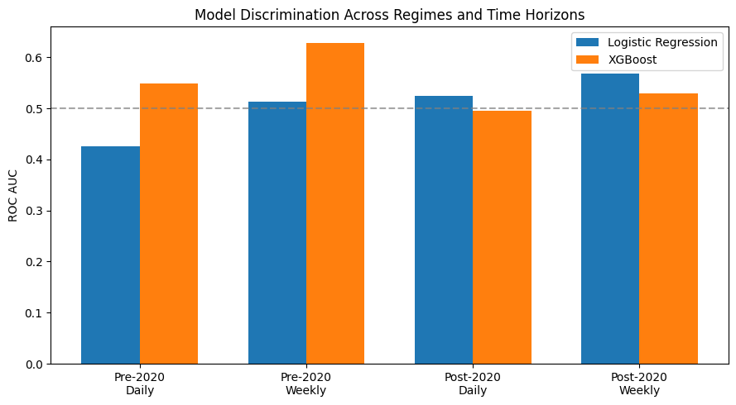
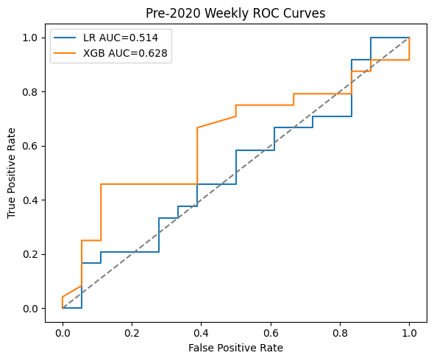
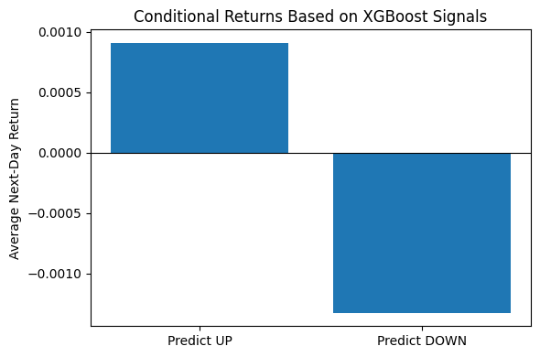
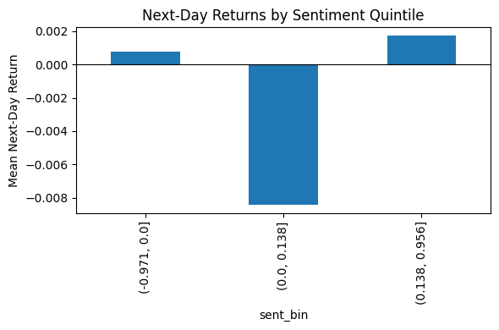
Across regimens and training horizons, the predictive signal is weak and non-uniform. Performances does seem to improve in weekly horizons. The XGBoost reached an AUC of 0.628 vs Logistic Regression hitting .514. While daily LR is worse than random, AUC .43~, and the daily XGBoost being .55. When I reran the models on post Covid sets, Logistic Regression did slightly better than XGBoost, suggesting a more linear/attenuated relationship in those feature sets. Despite modest AUCs, economic directionality is coherent. When XGBoost predicts up, the average next day return is .09%; when it predicts down, there is typically a -.13% return.

Discussion/Conclusions
One of the core lessons of applied quantitative work is that most plausible hypotheses weaken under rigorous testing. In this project, I tested whether daily news sentiment meaningfully correlated with end of day/week stock returns. The evidence suggests that while a relationship exists, it is small and unstable at short horizons. In expectation, the model’s Up signals are followed by modest returns (+0.09%) while Down signals are followed by modest negative returns (-0.13%). That asymmetry points to a weak economic signal, but one that is far from decisive and is easily overwhelmed by noise, transaction costs, and regime shifts.
At the same time, weak average effects often mask more structured and conditional behavior. This raises several follow-on questions worth investigating.
- Are positive days statistically more frequent than negative days in the sampled period? And does that frequency change across regimes?
- Do good sentiment days produce a fat-tailed distribution where a small number of outsized moves drive the mean, while most days cluster near zero?
  - What is the spread between typical moves and the upper tail?
  - Does sentiment meaningfully shift that distribution?
While these results are close to a null hypothesis for strong predictability, they still motivate deeper analysis, especially around conditional effects, horizon selection, and distributional outcomes. Work could easily be pursued with richer features and broader coverage.

